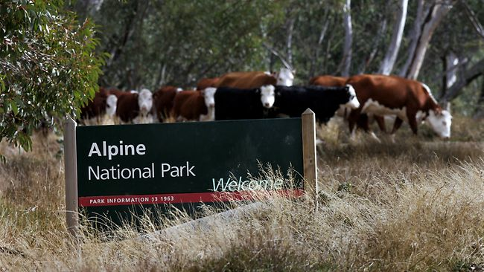
4.2.1- Conflicts of interest over the
use of OE’s
4.2.2- Methods used to influence
decision makers.
4.2.3- Processes used to resolve
conflicts over the use of OE’s.
Note:
This work book looks at the first three topics from this area of study due to the way in which they are so closely related.

It is important to remember the following points that are guided by the study design:
These two conflicts relate the best to areas studied and visited across the year.
Grazing – Bogong
GFNP- Yarra Ranges
- You need to be across at least two current/recent conflicts
- Grazing in the Alpine National Park
- Proposed creation of the Great Forest National Park
- You need to be aware of methods used by interest groups to
try and influence decisions made about the use of OE’s.
- You need to understand the different processes used by land
managers or governments or their agencies when they address
conflicts over the use of OE’s.

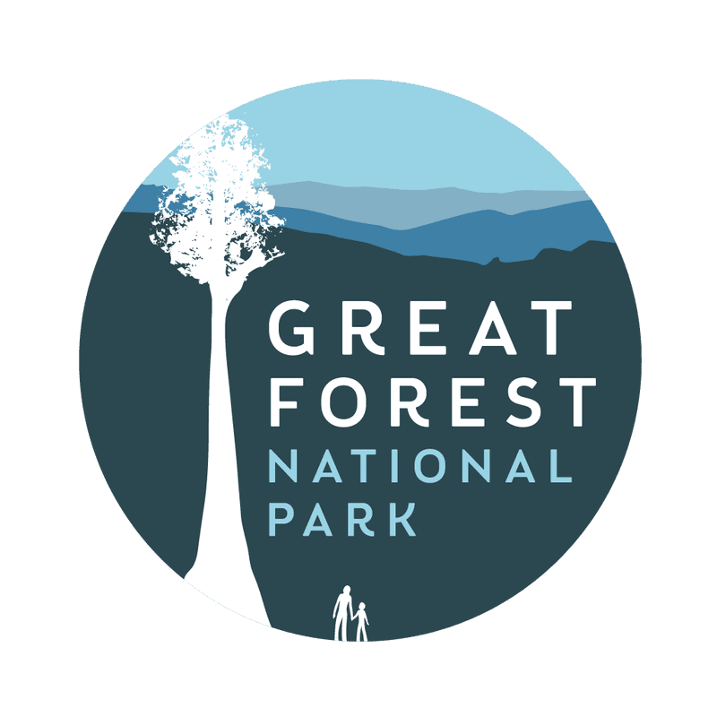

Conflict 1: Grazing in the Alpine National Park
You are to conduct research into the alpine grazing issue. Search online to research the fundamental groups involved, which are:
- Mountain Cattlemen’s Association of Victoria (MCAV)
- Victorian National Parks Association
Timeline of the grazing conflict:
- Outline the basis of the conflict:
- What environment is involved?
- What groups/parties are involved?
- What interactions with the environment are causing the different points of view?
- Why can’t this be resolved with compromise?

- Outline the major opposing groups, including:
- Who are they?
- Their views of the specific environment (perceptions)
- Their interactions /intended interactions with the specific environment

- Outline the methods used by the groups to try and influence the decisions over the use of the specific environment:
- Name the methods (at least x2 for ea.)
- How were they used in relation to the specific conflict – describe them…
- Evaluate them- were they effective or not? Why?

- Outline the processes used to make decisions about the specific environment:
- Explain the type of process (eg. Court action)
- Outline the details about how this process was used and by whom.
- Evaluate how effective this process was in resolving the conflict and why (was the conflict resolved?)

Conflict 2: Proposed creation of the Great Forest National Park
You are to conduct research into the GFNP conflict. Search online to research the fundamental groups involved, which are:
- Great Forest National Park Action Group
- Forestry industry & Recreational interest groups

Timeline of the GFNP conflict:

- Outline the basis of the conflict:
- What environment is involved?
- What groups/parties are involved?
- What interactions with the environment are causing the different points of view?
- Why can’t this be resolved with compromise?

- Outline the major opposing groups, including:
- Who are they?
- Their views of the specific environment
- Their interactions /intended interactions with the specific environment

- Outline the methods used by the groups to try and influence the decisions over the use of the specific environment:
- Name the methods (at least x2 for ea.)
- How were they used in relation to the specific conflict – describe them…
- Evaluate them- were they effective or not? Why?

- Outline the processes used to make decisions about the specific environment:
- Explain the type of process (eg. Court action)
- Outline the details about how this process was used and by whom.
- Evaluate how effective this process was in resolving the conflict and why (was the conflict resolved?)

Practice exam question:
2018 – EOY exam
Question 5 (13 marks)
Select one of the following environmental conflicts by ticking () the box beside it:
- marine national parks and sanctuaries
- grazing in the Alpine National Park
- desalination plant at Wonthaggi
- proposed Great Forest National Park
- extraction of coal seam gas

- Explain the selected conflict, including the different parties involved and the situation that started the conflict. 5 marks
(10 lines were provided for this question)

- Identify two of the main opposing groups and describe a method used by each group to influence decision-makers. 4 marks
Group 1
(7 lines were provided for this question)
Group 2
(7 lines were provided for this question)

- Evaluate the effectiveness of a process that has been, or could be, used by land managers and/or the government to resolve the selected conflict. 4 marks
(8 lines were provided for this question)

