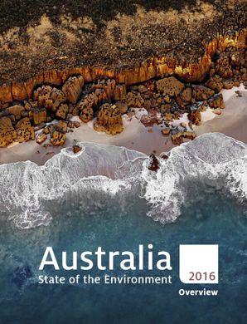
4.1.3- State of outdoor environments in Australia today
https://soe.environment.gov.au/
Using the 2016 State of the Environment report (most current), and your text pg.272-275:

- Outline what are State of the Environment Reports (SoE), who produces them and their purpose.

- Briefly describe each of the themes used in the SoE report.
Atmosphere
Biodiversity
Coasts
Inland Water
Land
Land
Heritage
Marine environment
Built environment
Antarctic

- Use the information prepared in class (re: Learning Task- 2016 SoE report) to complete the following table for each of the themes outlined in the SoE report.
Theme | Pressures | Current state and trends | Effectiveness of management | Resilience | Risks faced | Outlook
Atmosphere
Built environment
Heritage
Biodiversity
Land
Inland waters
Coasts
Marine environment

Research shows that cattle grazing in alpine areas affects the soil and changes the composition of plant species, effectively altering the type of environment present.

- Explain which of the SoE themes is being addressed by the above information and how it could be used to evaluate the health of an outdoor environment.

- Investigate: consider an environment you have visited or investigated this year. Examine the current state of this specific outdoor environment.
- Describe the positive and negative aspects of this environments health.
- Identify threats (pressures) that are influencing the health of the specific environment.
- Describe the management initiatives in place to address the threats and environmental concerns.

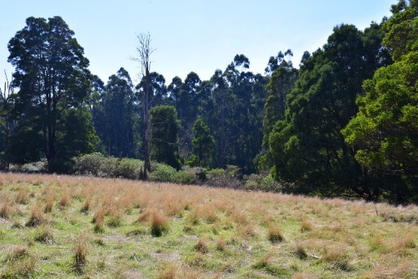
State of the Environment: Practice for SAC
Sherbrooke Forest- Dandenong Ranges National Park

TASK:
- Investigate the health of Sherbrooke Forest East in the Dandenong Ranges National Park by assessing observable characteristics.
- Use this information to develop a State of the Environment report for this environment.

Part 1 – Overview of the environment
This should include:
- Can you describe this environment?
- Consider the observable characteristics for measuring the health of the environment:
- Water quality and adequacy  - Air quality and adequacy  - Soil quality and adequacy | - Biodiversity  - Pest and Introduced species
What can you tell about this environment in reference to each of these?
- Use at least 3 of the above indicators to write an evaluation on the overall health of this?

Part 2 – The State of the Environment
- Provide a brief description related to three (3) of the following themes:
- Atmosphere | - Heritage
- Water | - Biodiversity
- Land | - Built environments

For each of these themes:
- A brief overview of the state of the environment as it relates to that theme.
- Identify at least 1 positive and 1 negative aspect of environmental health at the location that relate to each selected theme.
- Outline how one of the observable characteristics (from Part 1) can be used to help support your evaluation on the State of this Environment.
- Identify any threats or pressures that are influencing the health of this environment, as relating to each theme (changed land use, climate change, pest and introduced species).
- A brief overview of the likely outlook for the environment into the future, in relation to each theme.

Part 3 – Potential Impacts of Environmental Threats
- Choose one (1) of the following threats to outdoor environments:
- Land degradation  - Introduced species | - Climate change  - Urbanisation.

For your chosen threat, develop an overview that includes:
- A description of the threat.
- Discuss the impacts of the threat on the environment at the location.
- A brief discussion of possible solutions and/or mitigation strategies for the threat.

