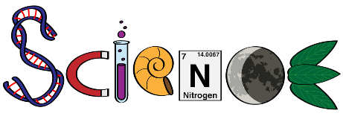
2.1.3- Scientific understandings of outdoor environments
This work book consists of three parts:
Part 1- The structure of natural systems and interactions between biotic and abiotic components.
Part 2- Effects of natural changes to environments on people and places, including: day/night, seasons, tides, flood, drought, migration, succession and climate change.
Part 3- The effect of fire (both wild and controlled) on the environment

Part 1- Structure of natural systems
- Describe what the biosphere is and the three components that is consists of.
- Outline the difference between a population of organisms and a community of organisms.
- A) Find a picture online of the water cycle and copy it into the box below.
B) Describe the process of the water cycle.

- Define the following words:
Ecosystem
Biotic
Abiotic
- Cut and paste the components listed below into the table to indicate whether they are biotic or abiotic components of the environment:
Wallaby | Red-back spider | Eucalyptus tree | Granite
Water | Nitrogen | Oxygen | Fire
Sunshine | Kangaroo Grass | Fungi | Precipitation

Biotic | Abiotic
- Describe the process of photosynthesis.
- Explain how energy is passed from one organism to another within a food web.
- Explain why the role of decomposers is important in a food web.

- Describe what would happen without the sun's energy to a natural system like the water cycle?
- What would happen overall without the sun's energy?

- Food chains and webs help to demonstrate the flow of energy in a natural system.
Use the food web below to answer the following questions:
- Outline three consequences of an unknown disease suddenly killing off the Cicada.

- All of the species shown in the food web, except for the cat, are native to the Australian environment.
It is widely recognized the how feral cats impact on many species in the environment.
Describe how removing the cat would be a benefit to this food web.

Part 2- Effects of natural changes to environments on people and places
- Outline each of the three levels at which change can occur within an environment:
Individual organisms
Community
Large-scale
- Describe, using pictures if necessary, the relationship between the sun, Earth’s position on its axis and the seasons. How do these elements interact to create seasonal variation?
- Describe the effects on people and the outdoor environment of the changing seasons.
- Tidal influence greatly impacts marine, coastal and estuarine (where rivers and streams meet the sea) environments. Investigate the relationship between the sun, moon and tidal flow.
Describe how these elements interact and why. You may include diagrams to help.

- Watch the video on the 2008 drought at the link below:
https://www.youtube.com/watch?v=u9s_A0G7oUU
- Describe some of the effects this video shows due to drought.

- Although drought is fairly common in Australia, what does the video suggest is increasing the frequency and impact of drought.

- Drought, Flood and even Fire are influenced by fluctuations in the climate. Australia’s climate patterns are influenced by both the El Nino and La Nina oscillation patterns.
Define both of these and identify which natural change to the environment they are likely to result in.
El Nino
La Nina
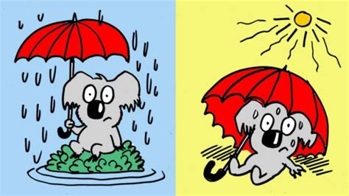
- Investigate the migratory patterns of a species that visits Australia as a part of its life cycle.
Produce a report that outlines your species migration, including:
- a description of when and why they migrate | - a map showing the path of the migration

http://environment.gov.au/biodiversity/migratory-species

(insert map)

- Investigate an environment you have visited (or will visit) or studied this year.
- Describe the long-term changes that have shaped this environment, including climatic, geological and vegetation changes.
- Briefly outline the short-term changes that this environment would most likely be effected by.
You can use images to assist your responses.

Part 3- The effect of fire
- Use the link below to answer the following questions regarding fire in Wilsons Promontory National Park.
https://www.ffm.vic.gov.au/media-releases/using-fire-to-restore-habitat-at-wilsons-prom
- How do we know that fire played a role in shaping the Wilsons Prom environment, long before any humans arrived?

- Describe a species whose life is dependent on fire and what affect a lack of fire would have on that species.

- Identify and explain the three factors that can determine the effect a fire has on the environment.
Factor | Effect

- Outline the two reasons given for conducting ecological burns on the environment.

- Describe what land managers (the people undertaking the prescribed burn) take into consideration before conducting a burn.

