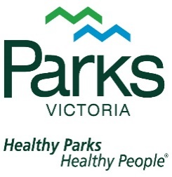
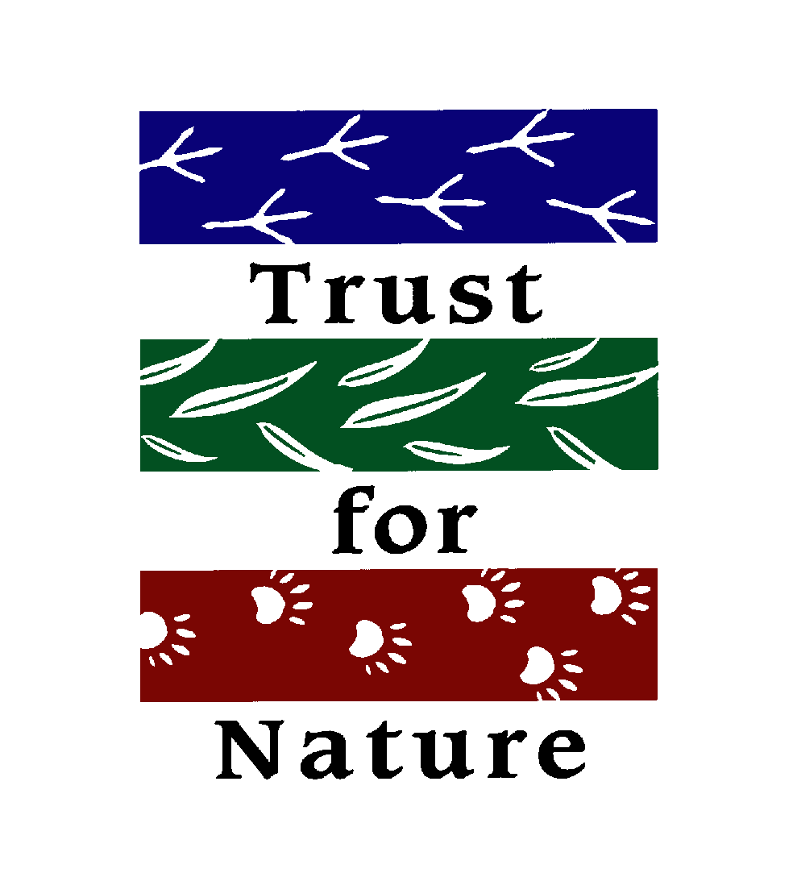
4.2.4- Management strategies for healthy and sustainable outdoor environments

Work Requirement Task:

Public Land Management
- Who manages what? Record the most relevant to areas we have studied or visited (or even for one you have visited and are familiar with).
Examples: Alpine NP, Grampians NP, Phillip Island Nature Parks, Yellingbo Nature Conservation Reserve, Emerald Lake Park.

Management Plans and Zoning
Every public land reserve in Victoria has its own individual management plan.
- Outline the aim of individual management plans

- Zoning is used within our parks and reserves to help with management.
Outline the different types of zone below and identify an example of where they are used.
Zone type | Definition | Location Example
Recreation / development
Conservation / recreation
Conservation
Wilderness
Reference

Read pg.325-327.
Visit Parks Victoria’s website and navigate to one of these public reserves:
- Australian Alps National Park
- Yarra Ranges National Park
- Grampians National Park
- Yellingbo Nature Conservation Reserve
Access the management plan for this Reserve and respond to the following:
- To do this, you need to use the “find” function
- Once you have opened the .pdf press ‘ctrl F’
- This opens a search tool that allows you to look for key words in the document- you don’t have to read a hundred page management plan!

- Identify your selected reserve:

- Outline the aim or purpose of this reserve.

- Describe any pressures on this outdoor environment (threats, problems, issues):

- Identify and outline any recreational uses and facilities provided to support these as identified in the management plan.

- Outline any management-based zoning of the Park.

- List strategies for the management of visitors to the Park.
- Provide two examples of actions that may be in conflict with the management objectives.
Ie: what is occurring in a park that contradicts the aims outlined in the management plan.

- Referring to the management plan, outline the key management objectives of the park or reserve for the future.

Management Strategies - Examples
- Using observations and experiences from environments studied, or even visited previously, to help develop a concept map that provides four examples (not including the example) of actions occurring to support management objectives.
(IE: we saw many examples at Phillip Island last year / many of you talked about these in your Healthy Outdoor Environment journal SAC / some will be identified and explained in the management plan you just used for Q.1-8)
Eg: Pest species control (animal)
Baiting is undertaken within this park in order to control fox numbers and reduce their impact on native wildlife

Park/Reserve:

Private Land management:
While ultimately in the hands of the land owner, the management of private land is influenced by government policy and organisations that aim to improve the health of these outdoor environments.
The majority of land (more than 60%) is privately owned, greatly restricting public access, but includes large areas with significant conservation value.

Visit the Trust for Nature website and use pg.327-329 to help with the following.

Trust For Nature (TFN)
- Outline the TFN.

Who are they?
What do they do?
What is their aim/objective?

- Explain why someone might choose to have a “conservation covenant” placed on a piece of land that they own.

- Describe the benefits placing a “covenant” on a piece of land give to that part of the outdoor environment?
- Define each of the main components of the TFN’s conservation program:
What are they? / How do they work?
Conservation covenants
Stewardship
Revolving Fund
TFN properties

