3.2.3- Social and Political Debates on environmental issues
Climate Change | Pg. 2-4
Water Management | Pg. 5-6
Renewable energy | Pg.7
Practice Questions | Pg. 8-9
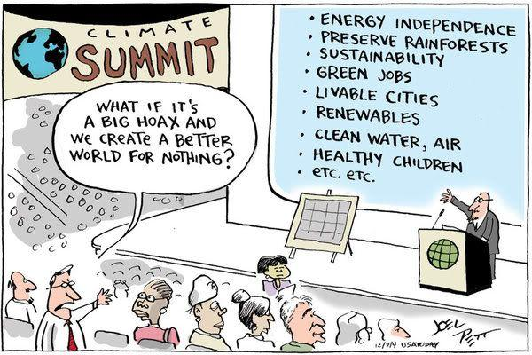
Contents:
- Many people don’t understand what climate change is.
How would you explain what climate change is to someone who doesn’t understand it?

Learning Task: “I can change your mind about climate change”
The following needs to be completed in your own time.
- Watch the documentary “I can change your mind about climate change” (available on the website/through the Library Catalogue/shown in class)
- Answer the following questions
- In the space below, record x3 key arguments that Tim and Anna use to support their respective positions.
Record the following:
- The name and qualification of who they visit
- Their key argument/supporting evidence

- Compare and contrast, what do both sides agree on and where do their opinions differ?

- Who or what is affected by either side being right or wrong?
- If climate change exists and we do nothing what are the possible outcomes?
- If climate change is a natural, a part of earths normal cycles, and we act to reduce it-
what is the possible outcome?

- What would it take to change your mind? (one way or the other)

Water management:
- Briefly outline one of the political/social debates surrounding water management in Australia.

- Outline how this debate could influence societal relationships with outdoor environments.

Learning Task: Melbourne’s Water Storage
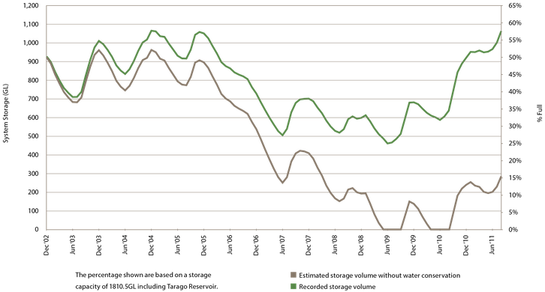
Refer to the graph above of Melboune’s water storage volume from 2002-2011.
- What would have happened if no water conservation techniques had been adopted in 2008-2010?
- How did climate conditions differ from the first half of the graph to the period in the second half?
- Research Melbourne’s water storage volume since 2011. How do you see Melbourne’s water storage coping in the future? Explain.

Renewable energy-
- Briefly outline the political/social debate surrounding renewable energy in Australia.

- For each of the renewable energy sources below, outline a positive and a negative.
ie: how might someone argue in favour of OR against using that energy source?
Energy Source | Positive | Negative
Solar
Hydro-electricity
Wave/tidal energy
Geothermal
Bioenergy

Learning Task: “A renewable battery”
Pumped Hydro-electric power
Consider the coalition governments plan to increase the capacity of the Snowy hydro scheme (Snowy 2.0) and turn it into a pumped hydro ‘battery’. This scheme uses solar energy to pump water uphill into a high reservoir during the day so as to ensure hydropower can be used into the night.
Use the following resources to research pumped hydro:
- http://www.climatecouncil.org.au/snowy-hydro
- https://youtu.be/VwoJmtm47aY

- Outline the pros and cons of this type of scheme.
Pros | Cons
- Evaluate the potential of pumped hydro for helping end Australia’s reliance on fossil fuels.

EXAM QUESTIONS
OES, Exam 2012

Question 2.
Read the following excerpt from Hansard (the Federal Parliament’s record of proceedings), dated 10 February 2011. The speaker is The Honorable Greg Combet AM MP, Minister for Climate Change and Energy Efficiency:
‘The Government is determined to tackle climate change. As a country, we are the highest per capita emitters of carbon pollution, and a carbon price is needed in our economy to cut pollution and drive investment in clean energy. The projected growth in our pollution to 2020 is 24 per cent above 2000 levels, which demonstrates the size of the challenge ahead of us. A price tag on pollution is the key to driving transformation in our economy. This will be a key debate this year that will influence the future of our country.
On the other side of this House, the Leader of the Opposition has the opportunity to take responsibility and stand up for the national interest of this country. So far, all we have heard from the Leader of the Opposition is ‘stop this’, ‘end this’, ‘don’t do this’, ‘no’ and stunning silences in certain interchanges. The Leader of the Opposition says no to everything—‘stop this’, ‘no’, ‘don’t do it’, ‘end this’. The most telling thing about his leadership of the opposition is that at no point has he stood up and taken a principled stand to support what is right and what is necessary in our national interest. This is a key opportunity. He needs to show the leadership that is necessary for this country on such a key challenge.’
- Describe one argument that could be used for supporting the approach of the Australian government in introducing a price on carbon emissions.

- Describe one argument that could be used for NOT supporting the Australian government’s price on carbon emissions.
2 + 2 = 4 marks
OES, Exam 2019
Question 5
The recent mass kill of over one million fish in the Murray-Darling river system has sparked a debate over how water is managed in Australia.
- With reference to the issue above or another water management issue that you have studied, explain two sides of a social and political debate about water management in Australia. 6 marks

- Analyse the effect of the debate explained in part a. on society’s relationships with waterways in Australia. 6 marks

OES, Exam 2018
Question 8
Analyse a debate about renewable energy and determine the impact of this issue on the relationships that people have with outdoor environments. (5 marks)

