3.2.2- Factors influencing contemporary societal relationships with outdoor environments

This key knowledge area is divided into four separate parts:

Factors | Page
1- The effects of different technologies | 2-4
2- Commercialisation of outdoor environments | 5-6
3- Portrayals of outdoor environments | 7-8
4- Social responses to risk taking | 9-10

From the study design:
- You are required to know about examples of each of these factors (listed above).
- You need to be able to evaluate the influence each of these factors has had on relationships with a specific outdoor environment.

Factor 1- The effects of different technologies
Ongoing technological advancement continues to influence almost every aspect of our society.
- Technological advances
Complete the table below using an outdoor activity of your choice.
- Choose an outdoor activity you are familiar with or have participated in before
- Research how technological advances have progressed over time (ie: in a piece of equipment that helps people participate in an outdoor activity).
- For example- Camping- 80 years ago = cooking would have been done on an open fire / 20 years ago = Trangia’s were becoming a common camp stove / Today = There is a huge range of stoves to cover camping in all sorts of conditions and environments (ones that run on gas, ones that use petrol / ones that are super light weight / ones that work in sub-zero temperatures
Outdoor Activity-
Technological advances | 80 years ago | 20 years ago | Today

- Technology Paradox – Class discussion
The paradox is that each new layer of invention and innovation simultaneously enhances and separates us from the outdoor experience.
Mike Bartle, Technology and Outdoor Education, 2000
- Discuss this quote using an example of an outdoor experience that you have participated in.
(eg: think about the Bogong Camp- climbing Bogong / Hiking on the High Plains / completing your solo)
- How has technology influenced your outdoor experience in this example?
- Was it enhanced? Did you feel that you had been separated from the outdoors?

- Influences of technology
Technology is able to greatly influence:
- PERCEPTIONS: the way outdoor environments are perceived
- INTERACTIONS: how we interact with outdoor environments
- IMPACTS: the impact we have on outdoor environments
Summarise each of the following influences on societal relationships using an example to support your response:

Alienation
Easier participation
Improves safety
Improves performance
Increases accessibility

Factor 2- Commercialisation of outdoor environments
- Commercialisation- Selling Australia
- On the ESCAPEOES website are the following videos:
    - Gruen Transfer “How do you sell Australia” – watch from 2.30 to 17min
    - 2006 and 2018 Tourism Australia ads – compare these and see if you can identify the elements of ‘Selling Australia’ identified in the Gruen Transfer
    - Selling Western Australia- Version 1 and Version 2

- Watch the Gruen Transfer episode:
Identify the key features that relate to OE that advertising companies use to try and sell a product.

- Explain how the two ad campaigns (2006 and 2018) are trying to work?
How do they use the features you have identified above?

- What don’t we see in these sort of ads?

- Watch the Western Australia ads (Version 1 and 2). Compare and contrast them– can you pick the differences between the two, and figure out why they’re different?
Who is each ad directed at?

- Outdoor Recreation Company
Research a commercial outdoor recreation company and respond to the following:
- Explain why the chosen provider is a commercial operation.
- Outline the venues utilised by this commercial operator
- How is the environment perceived in their advertising
- Outline TWO ways this company is interacting with the outdoor environment
- How could this type of outdoor experience:
  - Encourage greater participation rates?
  - Cause decreased participation rates?
- How could the operations of this commercial operator impact negatively on the natural environment?
- Outline two ways that this commercial operator can minimise their environmental impact

- Influences of commercialisation
Commercialisation is able to greatly influence:
- the way outdoor environments are perceived
- how we interact with outdoor environments
- the impact we have on outdoor environments
Use the table on pg.208 to help summarise each of the following influences on societal relationships:

Companies focused on using the environment to make as much money as possible by organising and running outdoor experiences
Companies use opportunity to promote and educate participants about appropriate outdoors behaviours
Companies package, market and sell outdoor experiences to anyone who chooses to spend their money that way
Companies package, market and sell outdoor experiences to anyone who chooses to spend their money that way

Factor 3- Portrayals of outdoor environments
- Summary of portrayals
Summarise each of the ways outdoor environments can be portrayed through the use of metaphors. (pg.143 and pg.209 of text book will help)
      - Adversary
      - Gymnasium
      - Resource/storehouse
      - Museum
      - Cathedral/Temple
      - Mother
      - Web

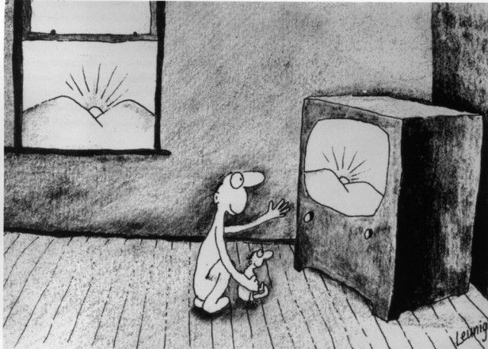
- Portrayals in media.
- Describe the scene in Michael Leunig’s ‘Sunset’ cartoon.
- What is the specific message is the artist trying to suggest with this piece of media?
- How is this piece of art trying to influence relationships with the outdoor environments?

- Portrayed in Music
Search online for a song with an environmental theme (or use one you already know).
Title:
Artist:
- Provide an excerpt from the song that demonstrates its environmental connection.
- Describe how is the environment portrayed in the song?
- Evaluate the effectiveness of this portrayal in providing the intended message (i.e. how successfully have they been able to influence perceptions on the environment and why?)

Factor 4- Social responses to risk-taking

- Incident sequencing-
Arrange the following responses according to the order in which they occur.
MEDIA COVERAGE OF INCIDENT | LEGAL PROCEEDINGS | REGULATION  -legislation -industry
INVESTIGATION INQUEST | TRAGEDY OCCURS | PUBLIC RESPONSE

1.
2.
3.
4.
5.
6.

- Case Study Debate - Death on Mt Bogong (2014)
The following links will take you to articles regarding the deaths of men who died while back country camping and snowboarding at Mt Bogong.
- Article 1
- Article 2
- Article 3

- Analyse the misadventure articles above.
*You will also be shown other media responses to the incident

- As a class, debate the following statement:
“Media portrayal of misadventure in outdoor experiences is exaggerated when compared with other mishaps in the community”

- Summary of social responses to risk taking
Societies responses to risk taking is able to greatly influence:
- the way outdoor environments are perceived
- how we interact with outdoor environments
- the impact we have on outdoor environments
Think about the Case Study from Question 5- Summarise how this case could relate to each of the following influences on societal relationships:
Media reports:
- Exaggerated
- Dramatized
Regulation of activities by:
- Industry
- Government
Including:
- Rules and regulations
- Restricted venue access
- Mandatory safety equipment
- Instructor : Participant ratios
- Training requirements
- Infrastructure

