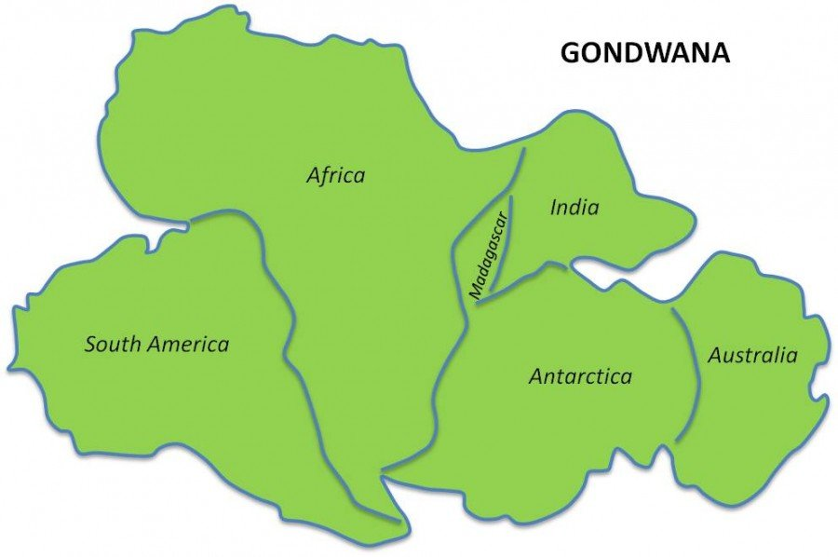
3.1.1- Australian before humans

The questions in the following document must be satisfactorily completed in order to successfully meet the requirements of this unit of work.

Work Requirement & Review Questions.
- Setting the scene:
List some of the key factors that make Australia unique:

- Define the four main phases that led to the formation of Australia. Ie: land formation, climate, flora and fauna.

- Identify three pieces of evidence for the connection between the countries that once made up Gondwana.

- There are three key characteristics that shape and define the unique Australian environment.
Define each characteristic:
BIOLOGICAL ISOLATION

GEOLOGICAL STABILITY

CLIMATIC VARIATION

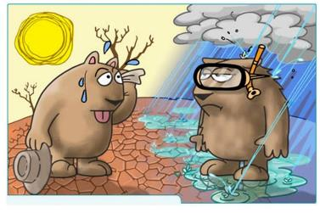

- Biological Isolation.
Explain, using an example or evidence, where we see this characteristic displayed within the Australian environment.

- Geological Stability.
Explain, using an example or evidence, where we see this characteristic displayed within the Australian environment.

- Climatic Variation.
Explain, using an example or evidence, where we see this characteristic displayed within the Australian environment.

- Fill in the table below regarding the adaptations of Australian Flora and Fauna.
 | Describe an example of an adaptation | Analyse the effectiveness of this adaptation
Flora
Fauna

- Explain how fire has played a significant role in developing the uniqueness of the Australian Environment.

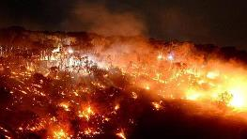

- Provide a definition of ‘Megafauna’.

Megalania prisca- At 7m long, was the largest lizard known to have existed.

- Megafauna were still present when the first indigenous people arrived in Australia and they lived alongside them for a long period of time before they disappeared.
Outline when the Megafauna become extinct and what led to their extinction.

TAKE THE QUIZ: What do you know about megafauna?
http://www.abc.net.au/science/games/quizzes/2009/megafauna/

3.1.1 –Australia before humans Practice Exam Questions

2022 Exam Question 1
Until approximately 10,000 years ago, megafauna were common in many parts of Australia. Megafauna included species such as giant kangaroo that could reach leaves 3 m off the ground and a giant wombat that was the size of a car.
Recently discovered fossil evidence suggests that both the last ice age and human interactions contributed to the extinction of the megafauna.
- Describe how two characteristics Australian outdoor environments before humans could have contributed to the extinction of the megafauna. (4 marks)

2016 Exam Question 1
Select one of the following characteristics of Australian outdoor environments before human settlement by ticking (☑) the box beside it:
☐ biological isolation
☐ geological stability
☐ climatic variation
Briefly explain how your selected characteristic influenced flora and fauna before human settlement in Australia. (3 marks)

