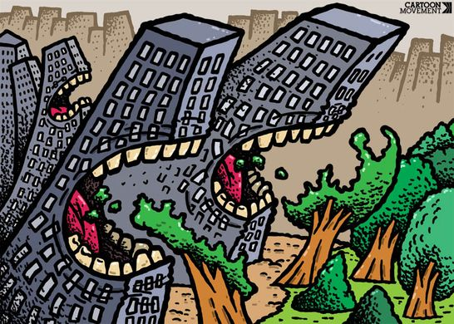
2.2.4- Urbanisation
The impact on outdoor environments of urbanisation and changing human lifestyles

- Impacts of urbanisation:
Consider the images from http://1945.melbourne/ and the typical impacts of urbanisation listed on pg.135

- Outline what similarities you notice between impacts on land and waterways.

- Can you identify any overlap? (ie: where a land impact could further a waterway impact)
Why might this be?

- Investigate one of the impacts to land or waterways and explain the consequence of this impact on the environment

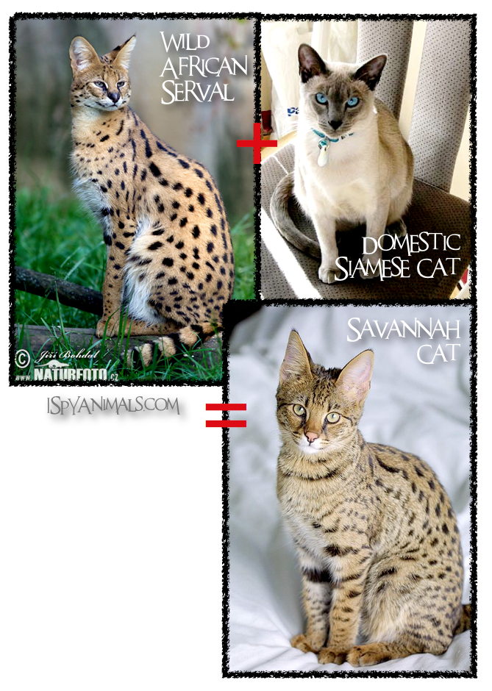
Learning Task: The Savanah Cat vs. The Australian Environment
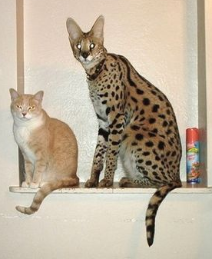
The class will be split in to three groups for this task
Group 1:
Savanah Cats Australia
- They wish to import the Savanah Cat to Australia as a domesticated breed, for showing and pet purposes
Group 2:
Wildlife Australia
- Are opposed to the importation of the Savanah Cat due to its potential impact on Australian wildlife
Group 3:
Biosecurity taskforce-
(a division of the Department of agriculture & water resources)
Tasked with evaluating this issue for the government to make a final decision on.
TASK:
- Group 1 and Group 2 will have two
minutes to present their individual cases.
- Group 3 must evaluate these arguments
and use their own evidence to support
their decision-
To import the Savanah Cat or not?

- Outline the main points raised by each of the three groups. What were their main arguments?
Group | Supporting arguments
Group 1:
Savanah Cats Australia
Group 2:
Wildlife Australia
Group 3:
Biosecurity taskforce

- The Australian government banned the importation of the Savannah Cat in 2008.
Read the summary of their decision at – Savannah Cat summary report.
Briefly outline why they decided not to allow Savannah Cats into Australia.

- Summarise the potential impacts of urbanisation on outdoor environments.

- Research one of the significant threats posed by urbanisation.
Describe this threat, its causes and the potential impacts it could have on society and outdoor environments.
Threat:

- Choose an outdoor environment you have visited or investigated this year. Identify and describe three significant threats to the health of this outdoor environment that relate to or are linked to urbanisation.
For each threat identified, explain its causes and the threats of potential impacts on society and the your chosen environment.

