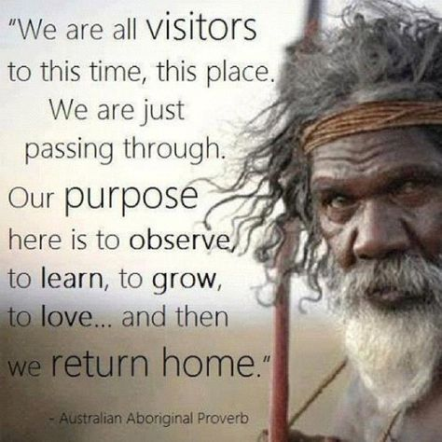
1.1.1- Ways of knowing outdoor environments

The questions in the following document must be satisfactorily completed in order to successfully meet the requirements of this unit of work.

Learning Task 1 – Acknowledgement of Country
- Clearly describe the difference between a Welcome to Country and an Acknowledgement of Country.
https://deadlystory.com-Welcomes&Acknowledgements

- Write an Acknowledgement of Country for an outdoor environment you have memories of visiting or previously studied (ie: regular camping spot, favourite beach, OE camp).
Reconciliation Australia advises the following:
- There are no set protocols or wording for an Acknowledgement of Country, just be sincere and, if possible, do some research on the Country you are acknowledging.
- Suggested wording could be: ‘I’d like to begin by acknowledging the Traditional Owners of the land on which we stand today, the (people) of the (nation), and pay my respects to Elders past and present’.
- Use the suggestions from the website above to help.

Learning Task 2 - Nature
- Knowing Nature:
The word ‘nature’ can be used in a wide variety of other contexts and situations.
Complete the table below to show how this occurs:

Use of ‘Nature’ | Context / Situation
Example:  nature versus nurture | Example:  This refers to the debate over a key aspect of human development- your genetic makeup (nature) versus the environment you are raised in (nurture).  Nature here is taken to mean the genetic code that is found in your cells and governs how your cells and body develop and operate
Human nature
The laws of nature
The nature of…..
Mother Nature

- The Nature Continuum

- Identify where you would place each of the following examples on the continuum.
- Describe why you have made each decision.
Examples: | Natural, Unnatural or Artificial? | Describe why…
Example:  Outdoor climbing area in a National Park | Example:  Natural | Example:  This is where people go and use the ‘naturally’ occurring environment to go rock climbing. They do not need to alter or change the environment.
Indoor climbing gym
Native (plant) garden
Revegetation area in a National Park
Small home aquarium
Large aquarium (think seaworld)

- Genetically Modified Organisms – Case Study
Background: | 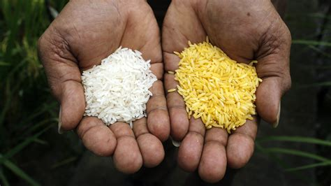  An interesting debate that has occurred in recent years is around the development of food that is genetically modified – called genetically modified organisms (GMOs). One example of a GMO is golden rice (called this because of its yellow colour).  Golden rice was engineered to include beta-carotene, a form of vitamin A, because of deficiencies in many developing world diets. It is estimated that around 670000 children under the age of five die each year because of this deficiency.  Other GMOs include genes for herbicide resistance, lowering cholesterol, virus protection, growth hormones and fruit decay. Are GMOs natural? The genes that are spliced into GMO foods are from other organisms, so they could be called natural. But when you put genes from one organism into another, is that natural? Many people don’t think so, and the debate has become very emotional. GMOs aren’t recent, though. Scientists from Peru have found a genetically modified sweet potato from approximately 8000 years ago. Would that be considered natural today or not?

Task: Analysing GMO debates
Find out about some of the debates concerning the development and use of GMOs and write a response that addresses the following:
- When you put genes from one organism into another, is that natural?
- What problems might this cause? Does it matter?
- What are some of the arguments used by people and groups who are for or against the ongoing development of GMOs?
- What is your overall opinion?
Learning Task 3 – Non-indigenous ways of knowing outdoor environments
- Wilderness
Outline each of the components that help classify an area as a ‘wilderness’.
BIG
REMOTE
UNTOUCHED

- Managed Parks
Fill in the table below regarding the different types of managed parks found in Victoria:
Park Type | Aim/Purpose
World Heritage Protected Area
National Park
State Park
Marine Parks
Wilderness Areas
Local & Metropolitan Parks

- Built environments- Artificial nature
Produce a report on an artificial or simulated environment such as an artificial reef, indoor climbing wall or indoor skiing centre.
Include in your report answers to the following questions:
  - What are some reasons why people would construct this type of artificial environment? (Give at least TWO reasons.)
  - Briefly describe an example of this type of artificial environment and include a picture to show what it looks like.
  - What might be some of the difficulties involved in constructing this type of artificial environment?
  - What might be some of the impacts (good and/or bad) of constructing and using one of these artificial environments?

Learning Task 4 – Outdoor Experiences
- Outdoor experiences allow the development of understandings of outdoor environments from various perspectives, including through:
- experiential knowledge
- environmental and natural history
- ecological, social and economic perspectives
Consider how you may already be able to relate to each of these based on your past outdoor experiences.
- Experiential knowledge
Outline 3 examples of where you have ‘gained knowledge’ through experiencing an outdoor environment.

- Environmental and natural history
Finish the timeline for the Emerald Lake Park area from past through to today:

Time | Events
500 years ago
 | The small settlement of Emerald was established when gold was discovered along the Menzies and Sassafras Creeks.
1886
1900
1913 | Much of the nursery area is involved in the growing of flax to make twine and rope for the war effort.  The creek was dammed to form Lake Nobelius (now known as Emerald Lake).
1930
1939
1941 | Emerald Lake Park officially opens
 | Puffing Billy closes due to landslide
1975

- Ecological, Social and Economic perspectives
Perspective challenge Re: Emerald Lake Park
For each perspective, answer the following questions:
- Who might ‘know’ the environment from this perspective?
- What is valuable or important about this environment in relation to this perspective?
- How would people come to know and understand the environment from this perspective?
Ecological Perspective
Social Perspective
Economic Perspective

